**FAST RATES FOR SUPPORT VECTOR MACHINES USING GAUSSIAN KERNELS**

Sanket Mundra(IIT2018189), Raunak Rathour(IIT2018196), Prateek Mishra(IIT2018199)

*VI Semester B.Tech, Department of Information Technology,*

*IIIT-Allahabad,Prayagraj, India*

***Abstract: In this assignment we have studied some optimization techniques to establish faster learning rates for a wide class of distribution in SVM.***

1. **INTRODUCTION**

Support vector machines have seen many theoretical considerations in the recent years. However, their learning performance on various classes of distribution still has a long way to go. We have studied concepts like local Rademacher averages and Tsybakov's noise assumption to improve learning rates upto n-1 for non-trivial distributions.

1. **ALGORITHM DESCRIPTION**

T = { (xi ,yi) } ϵ ( X ｘ Y)ⁿ

Classifier C uses ft : X→**ℝ**

1. Taking gaussian kernel  
   kf(x,x’) = e^(-α2 ||x-x’||22)  
   where x,x’ belongs to X  
     
   kf here is the gaussian kernel and f is the free variable,   
   such that f>0.   
     
   We have taken RBF kernel here.
2. Consider gaussian RKHS  
     
   The numbers which are covering is N, which is:

N(A,ε,e)

=min{n>=1 : h(x,ε,e)∃x1,...,xn}  
  
where A⊂E is branch subset of branch E.

1. Application of SVM over this sub branch with  
    σ>2√d.
2. Error estimation is calculated as -  
    E(x) = 1 - e-x
3. **RESULT**

The accuracy of execution with different kernels are shown in Fig1.

**Fig.1**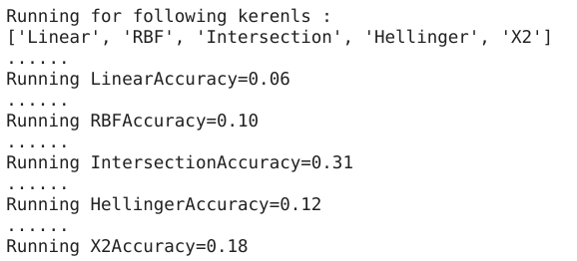

1. **CONCLUSION**

In this paper we studied the proposed geometric noise assumption to determine properties of gaussian kernels to be used in SVM later. These assumptions described the concentration of the measure of |2n - 1| d Px - where Px is the marginal distribution of P with respect to x.

1. **REFERENCES**

[1] Steinwart, Ingo and C. Scovel. “Fast rates for support vector machines using Gaussian kernels.” Annals of Statistics 35 (2007): 575-607.

[2] Dong, Jian-xiong, Adam Krzyzak, and Ching Y. Suen. "Fast SVM training algorithm with decomposition on very large data sets." IEEE transactions on pattern analysis and machine intelligence 27.4 (2005): 603-618.

[3] Shakhnarovich, Gregory, Paul A. Viola, and Baback Moghaddam. "A unified learning framework for real time face detection and classification." Proceedings of Fifth IEEE international conference on automatic face gesture recognition. IEEE, 2002.

[4] Chen, Datong, Hervé Bourlard, and J-P. Thiran. "Text identification in complex background using SVM." Proceedings of the 2001 IEEE Computer Society Conference on Computer Vision and Pattern Recognition. CVPR 2001. Vol. 2. IEEE, 2001.